INF1342: < ICT and Smart Food Bank>

System Requirements and Architectural Design

<04-09-2019>

# Contents

|  |  |  |
| --- | --- | --- |
| 1 | The purpose of the project | 3 |
|  | 1.1 The User Business or Background of the Project Effort | 3 |
|  | 1.2 Goals of the Project | 4 |
| 2 | The Stakeholders | 4 |
|  | 2.1 The client | 4 |
|  | 2.2 The Customer | 5 |
|  | 2.3 Other Stakeholders | 5 |
| 3 | Constraints | 7 |
|  | 3.1 Solution Constraints | 7 |
|  | 3.2 Implementation Environment of the Current System | 7 |
|  | 3.3 Partner or Collaborative Applications | 7 |
|  | 3.4 Off-the-Shelf Software | 7 |
|  | 3.5 Anticipated Workplace Environment | 8 |
|  | 3.6 Budget Constraints | 8 |
|  | 3.7 Schedule Constraints | 8 |
| 4 | Naming Conventions and Terminology | 8 |
|  | 4.1 Glossary of All Terms, Including Acronyms, Used by Stakeholders Involved in the Project | 8 |
| 5 | Relevant Facts and Assumptions | 9 |
|  | 5.1 Relevant Facts | 9 |
|  | 5.2 Business Rules | 9 |
|  | 5.3 Assumptions | 9 |
| 6 | The Scope of the Work | 9 |
|  | 6.1 The Current Situation | 9 |
|  | 6.2 The Context of the Work | 9 |
|  | 6.3 Work Partitioning | 10 |
| 7 | Business Data Model and Data Dictionary | 10 |
| 8 | The Scope of the Product | 11 |

|  |  |
| --- | --- |
| 8.1 Strategic Dependencies | 11 |
| 8.2 Product Boundary | 12 |
| 8.3 Product Use Case Table | 13 |
| 8.4 Product Use cases | 13 |
| 9 Functional Requirements | 14 |
| 10 Non-Functional Requirements | 20 |
| 11 Architectural design | 23 |
| 11.1 Key drivers and Architecturally Significant Requirements | 23 |
| 11.2 Context View | 25 |
| 11.3 Key architectural design decisions | 25 |
| 12 Open issues | 28 |
| 13 Changes made in the course of analysis | 31 |

*We acknowledge that this document uses material from the Volere Requirements Specification Template, copyright © 1995 – 2015 the Atlantic Systems Guild Limited*.

# THE PURPOSE OF THE PROJECT

## THE USER BUSINESS OR BACKGROUND OF THE PROJECT EFFORT

**Food insecurity as a sever issue:**

Food insecurity is considered a big issue that faces societies and hiders the productivity of individuals. It can be described as running out of food or limited food selection because of the lack of money, which also involves compromising the quality of food. Household food insecurity can be a result of financial restraints. It is a very serious problem in Canada and greatly impacts the mental and physical health of the individuals. It also costs the healthcare system considerably due to the need for treating the food insecure individuals. The recent The Household Food Security Survey Module (HFSSM) on the Canadian Community Health Survey (CCHS) statistics show that 1 I 8 households in Canada is food insecure resulting in over 4 million Canadians insecure with 1.15 million children among them. The numbers on insecure houses increased significantly from 11.3% in 2007 to 12.4% in 2011 and the numbers are projected to increases further. The research found that over 60%, of food-insecure households, are relying on wages and salaries as their main source of income and having a job is not enough to cover all the food needs in the households. It hinders people from good health, it affects the children’s wellbeing and can result in increased risk of developing depression.

## Available solutions:

Knowing the dangerous effects of food insecurity, the government provides the lower income families extra money to help suffice their food needs.

Apart from allowance, Foodbanks are being supported by donors and companies to provide the people in need with extra food to help them reduce the effects of food insecurities. However, research has shown that most food insecure households do not use food banks and they do not move families out of the food insecurity risks.

Food banks are very important to help insecure families get the food they need. Statistics found that 35.2% of the people relying on food banks are children, these numbers show that the food bank should do its best to provide these children with the food they need. Foodbanks also support anyone who is food insecure. The foodbanks work with their communities to support the people who need food.

Although foodbanks are doing their best to help people who need food, the service is limited because of the government cuts. The foodbanks depend heavily on food donations, and sometimes these donations are not enough to fill the people’s needs. Most of the times, the quality of food donated to the foodbank is not good enough and the food they give does not match the people’s needs.

## Motive behind our system:

The lack of food supports, coordination between the people’s needs and the food the foodbank can have and advertising for donations limit foodbanks’ ability to provide help. We came up with the idea to create a smart food bank system which will allow the food bank to request the needed food instead of receiving any food that does not match the people requests. It will also allow the food bank to coordinate and connect with the donors to allow them to donate food and connect with the people in need.

## GOALS OF THE PROJECT

The goal of the project is to help to minimize the effects of food insecurities on individuals and improve the service of foodbanks. The biggest concern we want to cover is supporting people with the needed food. Instead of giving people what we have in the storage room, we will allow people to request the food they desire and need, and we will do our best to order the food for them or providing them with the best substation if the food cannot be provided. Another issue the food bank faced with is the donated food quantity. Sometimes the food bank receives so much food and it goes to waste and sometimes they don’t receive enough. Our system will only order the exact quantity the people in need require so that we fill their needs and save food from wastage. Communication with the donors is big issue food banks facing, the big donors (companies) only connects with the big distributors (Daily bread and second Harvest) therefore they don’t know the foodbanks needs and they prove them with whatever they decide to give. To fix this issue, our system will facilitate the communication between the foodbanks and the big donors, which will allow them to understand the foodbanks needs and provide them with the needed food only to save food from wastage and fulfill people’s needs. Another issue the foodbanks facing is advertising. A lot of food goes to wastage and people don’t know about the food banks or their locations. To fix this issue and get people to donate more to the foodbanks, our system will have a portal where we ask for needed food to be donated. This can be done when the big donors fail to provide the foodbank with the needed food, the portal will allow the foodbank manager to post the list of food they need to fulfill people's needs.

## Overall goals:

* + 1. Provide the people in need with the food they require rather than the food the foodbank have.
    2. Provide people in need with enough food.
    3. Facilitate communication between the foodbank and the big donors.
    4. Encourage people to donate to the foodbank.
    5. Engage more with the foodbanks and provide them with the needed food through the portal.
    6. Save food from wastage and reduce the effects of food insecurities.

# THE STAKEHOLDERS

## THE CLIENT

**Foodbank Manager** plays an important role in organizing food donation and food distributions. The responsibilities of the Foodbank Manager are:

* + 1. Accept people in need’s food request
    2. Request foods based on people in need’s request from big donors
    3. Publish the notification of needed food to individual donors
    4. Organize food distribution by categories and expired date

## The motivation of the Foodbank Manager:

Distribute food fairly and match people ‘s request, help to provide the people who need food with the food they need to fulfill their needs and do his/her best to request the food to the people and match their needs.

## THE CUSTOMER

**People in need** are a group of people who come to foodbanks weekly to request food based on what they need. These people are defined as people food insecure people and they seek the foodbank help to provide them with food to cover their food needs.

**Motivation:** get food to support themselves and support their families.

**Big donors** are a group of companies who want to help the people in need by providing them with the extra food that can help them cover their food insecurity.

**Motivation:** Provide the food banks with the food they need and help Canada tackle the food insecurity problem and also get rid of the extra food they have instead of wasting them.

**Individual donors** are the group of people who would like to donate their food individually in order to help people in need to get what’s their needs.

**Motivation:** Provide the food banks with the food they need and help Canada tackle the food insecurity problem and also get rid of the extra food they have instead of wasting them.

## OTHER STAKEHOLDERS

|  |  |  |  |
| --- | --- | --- | --- |
| **Core Product design team:** | **Regulators:** | **Internal Staff:** | **Distributors:** |
| project manager | Government | Food bank volunteer | Second Harvest |
| System tester/ analyst | Professional associations | Marketing staff | Daily Dairy |
| Developer | Non-profit organization | Business analyst | **Sponsors** |
| UI/UX designer | N/A | Technology analyst | **Negative stakeholders** |
| System administrator | N/A | Delivery Trucks | N/A |

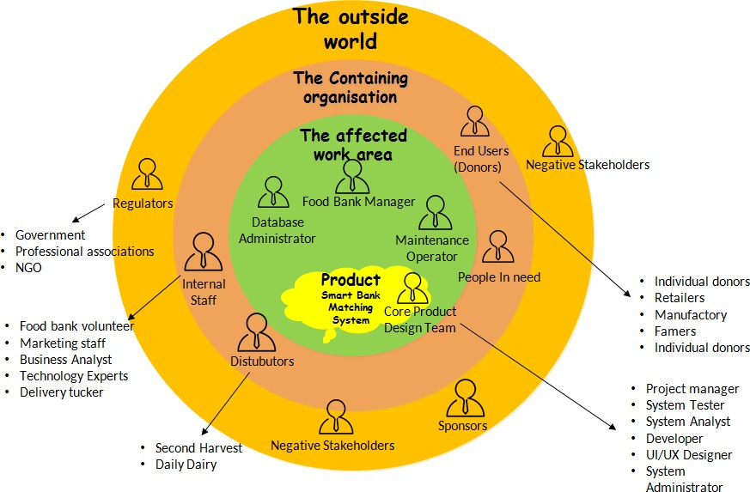

*[Figure 2] Onion Diagram*

## Stakeholder Table

|  |  |  |  |  |  |
| --- | --- | --- | --- | --- | --- |
| **#** | **Stakeholder Identification** | **Knowledge needed by the project** | **Degree of involvement** | **Degree of influence** | **Agreement on how to resolve conflicts with stakeholders with similar**  **interests** |
|  | Foodbank | How they run | Very High | Very High | There is no conflict all the |
|  | Manager | the food bank. | (10/10) | (10/10) | food banks and the |
|  |  | Where they get |  |  | charities run under the |
|  |  | the food from. |  |  | government. |
|  |  | What kind of |  |  |  |
|  |  | donations do |  |  |  |
| 1 |  | they accept? |  |  |  |
|  | People in need | How often they | High (8/10) | High (8/10) | There is a competition |
|  |  | use the food |  |  | because the food bank |
|  |  | bank. |  |  | runs based on first come |
|  |  | They type of |  |  | first serve basis. To fix this |
|  |  | people need to |  |  | the food bank |
|  |  | use the |  |  | recommends the people |
| 2 |  | foodbank. |  |  | who do not have spot to join other food banks. |

|  |  |  |  |  |  |
| --- | --- | --- | --- | --- | --- |
|  |  | The quantity of food people usually asks for |  |  |  |
|  | Individual | Who donates | Medium | Medium | No competition, everyone |
|  | donors | the food? | (6/10) | (5/10) | can donate and help the |
|  |  | what type of |  |  | people in need. |
|  |  | donations they |  |  |  |
| 3 |  | provide |  |  |  |
|  | Organization | Who donates | Medium | Medium | No competition, everyone |
|  | donors | the food? | （6/10） | (6/10) | can donate and help the |
|  |  | what type of |  |  | people in need. |
|  |  | donations they |  |  |  |
|  |  | provide and the |  |  |  |
|  |  | quality and |  |  |  |
|  |  | quantity they |  |  |  |
| 4 |  | can provide |  |  |  |

1. **CONSTRAINTS**
   1. **SOLUTION CONSTRAINTS**

**Description:** The ICT food bank system shall operate using Microsoft Windows 7.

**Rationale:** The foodbank manager uses Microsoft Windows 7 and does not wish to change to a later version.

**Fit criterion:** The ICT food bank system shall be approved as Microsoft Windows compliant by the IT group.

**Description:** The ICT food bank mobile application shall operate using the Android system.

**Rationale:** The individual donor/people in need use the Android system and does not wish to change to another system, such as IOS.

**Fit criterion:** The ICT food bank mobile application shall keep updating the Android system version by the IT group.

## IMPLEMENTATION ENVIRONMENT OF THE CURRENT SYSTEM

N/A

## PARTNER OR COLLABORATIVE APPLICATIONS

N/A

* 1. **OFF-THE-SHELF SOFTWARE**

N/A

## ANTICIPATED WORKPLACE ENVIRONMENT

1. The food bank’s storage room should be clean and dry to keep the donated food.

## BUDGET CONSTRAINTS

1. Since the food bank is a not-for-profit organization, the monthly operation cost shall be in time to account by the government.

## SCHEDULE CONSTRAINTS

N/A

# NAMING CONVENTIONS AND TERMINOLOGY

## GLOSSARY OF ALL TERMS, INCLUDING ACRONYMS, USED BY STAKEHOLDERS INVOLVED IN THE PROJECT

1. **ICT:**

Information and Communications Technology. ICT focuses primarily on communication technologies and includes the Internet, wireless networks, cell phones, and other communication mediums.

## Food Security:

Food security means having reliable access to enough good, healthy, and culturally appropriate food.

## Smart Foodbank:

Smart Foodbank is a key participant that collects food from donors and distributes it to people in need with the help of a new ICT system.

## People in need:

People in need are people who get food support from the Foodbank, who usually have a lower family income and cannot afford enough high-quality food.

## Big donors:

Large organizations could be big retailers, food factories and food distributors that possess extra food in large quantity.

## Individual donors:

Individual donors can be any people who have extra can food and want to make good use of them by donating them to people in need.

# RELEVANT FACTS AND ASSUMPTIONS

## RELEVANT FACTS

* + 1. The Smart Foodbank has limited storage room.
    2. The system processes the information (food request) in internet connection.

## BUSINESS RULES

* + 1. People in Need shall pick up their requested food as claimed in their requests.
    2. The Smart Foodbank will hold the requested food order for up to two days.
    3. If people in Need do not pick up the food as requested, the food will be backlog into the system as next weeks’ donation.
    4. The food will be distributed in first request first serve basis.

## ASSUMPTIONS

* + 1. We assume that the donors will only donate food as requested.
    2. We assume that foodbank has the full capacity to function on itself without any support from a third party such as a second harvest.
    3. We assumed the big donors and the individual donors would more or less provide the weekly requested food.

# THE SCOPE OF THE WORK

## THE CURRENT SITUATION

The current situation is that the foodbank will collect whatever donation the bank can possibly collect and give out to the people in need without considering people’s actual need. The foodbanks give small families the same amount as big families. A lot of food is expired, and the quality is not good and they depend on second harvest and daily bread to provide them with food every week.

## THE CONTEXT OF THE WORK

* 1. **WORK PARTITIONING**

|  |  |
| --- | --- |
| **Actors** | **Work Partition** |
| **The Smart Foodbank manager:** | 1. Publish food list for the People in Need to request. 2. Aggregate food in need. 3. Contact big organization donors to realize food donation. 4. Publish food shortage to guide individual donors. 5. Log in all realized food donation. 6. Pack food. 7. Assist the People in Need for picking up. |
| **The People in Need** | 1. Fill in food requests. 2. Pick up food as requested. 3. Cancel request in time if needed |
| **The big organization donors** | 1. Donate food as requested by the Smart Foodbank managers. |
| **The individual donors** | 1. Donate food as listed on the food shortage page. 2. Bring the food to the Smart Foodbank. |

1. **BUSINESS DATA MODEL AND DATA DICTIONARY**

**Business Data Model**

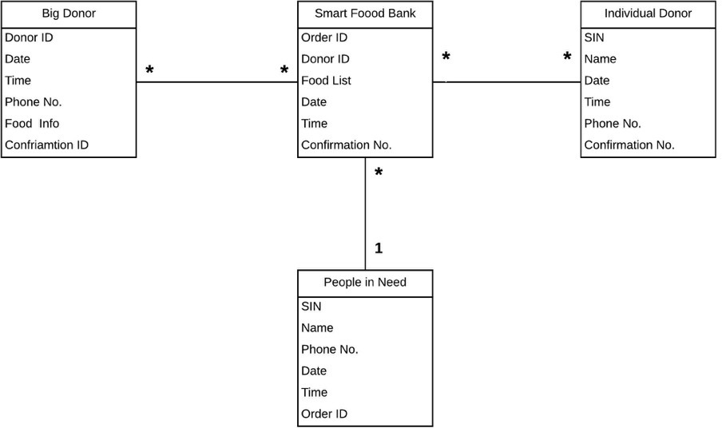

*[Figure 7.1] Business Data Model*

The Smart Food Bank shall have many individual donors to donate the food. Each individual donor shall go to different Smart Food Banks to donate the food. The Smart Food Bank shall distribute food to many people in need. Every people in need shall go to one Smart Food Bank to get the food. The Smart Food

Bank shall have many cooperation with different big donors to request food donation. Different big donors can cooperate with different smart food banks.

## Data Dictionary

N/A

# THE SCOPE OF THE PRODUCT

## STRATEGIC DEPENDENCIES

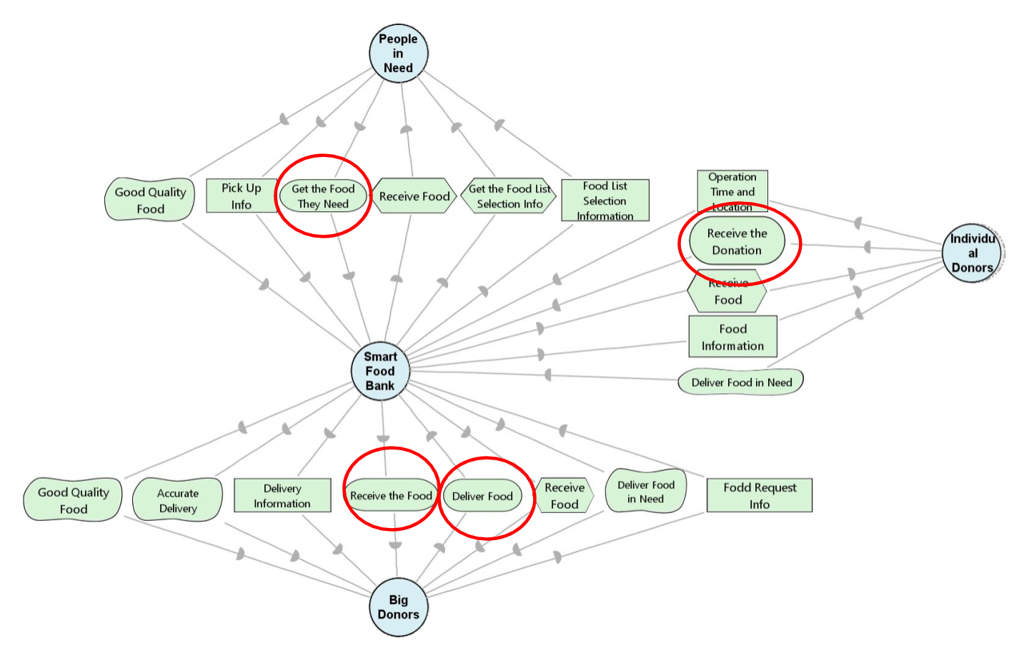

*[Figure 8.1] i* SD diagram*

From our i* SD diagram, we found that there are four main actors, which are people in need, food banks, individual donors, and big donors. The people in need main objective is to get the food they need from the food bank. Smart food bank hopes to receive the food from the big donors, as it distributes food to the bank. Recognizing all the goals and the dependencies of the system will help the smart food bank to receive, distribute and match the food efficiently. Knowing this relationship and dependency we can conclude that: the main goal of the food bank is to receive food requests from the people in need and order the food from the big companies and the donors to provide them with the food they need.

The big donors aim to deliver the food they can provide to the food bank on time. The individual donors

want to help as much as they can by providing the food they can provide and the people in need aim to receive food that would help them have enough food to support themselves.

## PRODUCT BOUNDARY

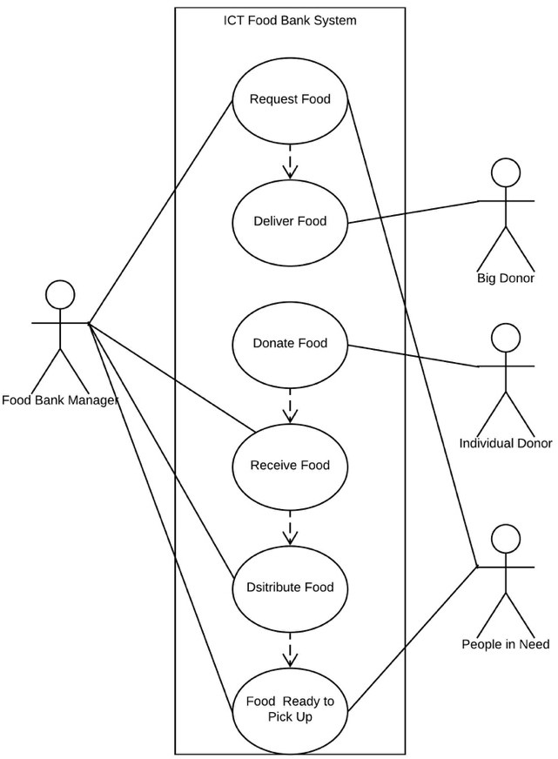

*[Figure 8.2] Use case diagram*

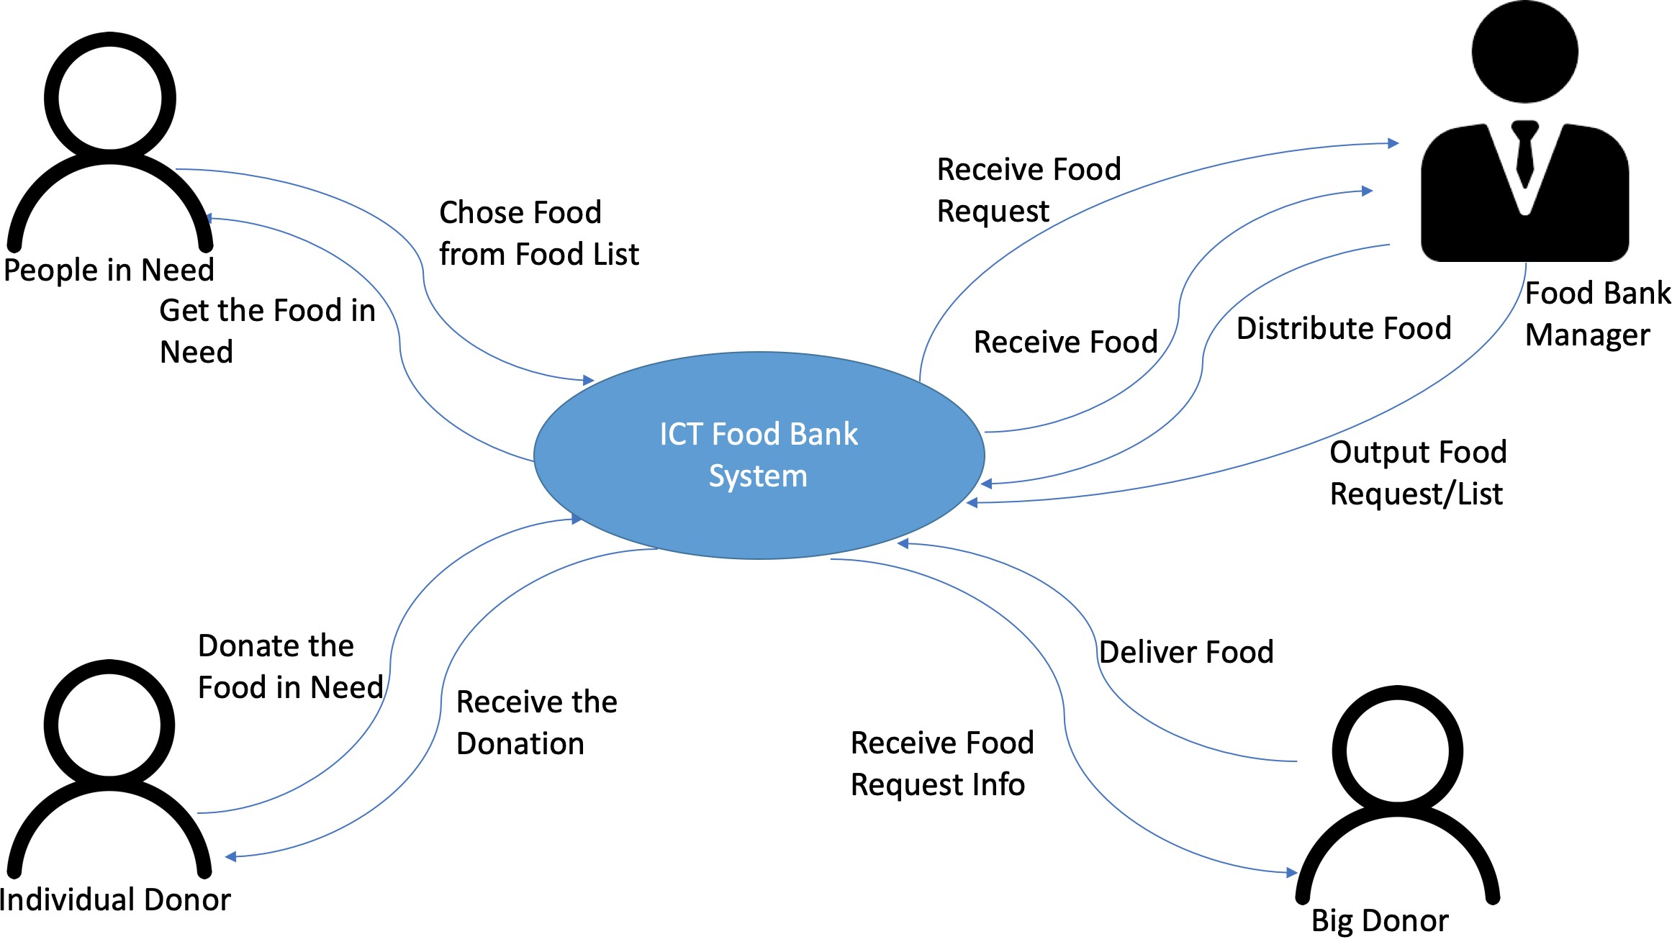

*[Figure 8.2.1] Product Scope diagram*

## PRODUCT USE CASE TABLE

|  |  |  |  |
| --- | --- | --- | --- |
| **Use Case** | **Description** | **Input** | **Output** |
| UC 1: Food Request | Online individual food requests collecting. | Food requests | Aggregated food demand. |
| UC 2: Food Donation - Big Organization Donor | Data aggregation and Food Donation collecting from big organizations. | Aggregated food demand | Realized food donation list/info |
| UC 3: Food donation - Individual Donor | Real-time difference calculating and Food Donation collecting from individual donors. | Food shortage list | Realized food donation list/info |
| UC 4: Food Distribution | Automated e- distribution on first request first serve basis. | Food donation, food request history | Food distribution result |

* 1. **PRODUCT USE CASES UC1: Food Request**
     1. The system administrator enters the possible donation food list and the system publishes the list online. **(Input: food list, output: N/A)**
     2. Users log in the system, choose foods, enter quantities, accept/wave substitution, and submit the request. **(Input: user entries, output: request)**
     3. The system stores requests and generates time-stamped receipts to users. **(Input: request, output: receipt)**

## UC2: Food Donation from big donors

1. The system automatically aggregates food requests after the portal is closed and sends the aggregated request to the food bank. **(Input: all individual requests, output: aggregated requests)**
2. The system administrator enters realized donation from big donors. **(Input: donation from big donors, output: N/A)**

## UC3: Food Donation from individual donors

1. The system automatically calculates the difference between the aggregated food requests and the realized donation. **(Input: all requests and realized donation, output: unrealized donation list)**
2. The system publishes the real-time unrealized donation list online. **(Input: unrealized donation list, output: N/A)**
3. The system administrator enters realized donation from individual donors. **(Input: donation from individual donors, output: N/A)**

## UC4: Food Distribution

1. The system automatically calculates which requests can be fully/partially achieved on a first come first serve basis. **(Input: all requests and all donation, output: fully/partially achieved requests list)**
2. The system sends notifications to users. **(Input: fully/partially achieved requests list, output: notification letters)**

# FUNCTIONAL REQUIREMENTS

|  |  |  |  |
| --- | --- | --- | --- |
| **Requirement ID:** <JS01> | **Requirement Type:** <Functional> | | **PUC:** <Food Request> |
| **Description:** The Smart Foodbank administrator shall enter a food list into the system for the People in Need to choose from. | | | |
| **Rationale:** The list is customized by the Smart Foodbank and mapped into the center database for future data aggregation. | | | |
| **Originator:** <The Smart Foodbank administrator> | | | |
| **Fit Criterion:** The administrator will enter food name, picture and basic description. The system shall publish the list online for people to fill the request form. | | | |
| **Supporting Materials:** Prepared food list | | **Conflicts:** N/A | |

|  |  |  |  |
| --- | --- | --- | --- |
| **Requirement ID:** <JS02> | **Requirement Type:** <Functional> | | **PUC:** <Food Request> |
| **Description:** The Smart Foodbank system shall allow People in Need to select food from the food list and enter quantities needed. | | | |
| **Rationale:** The list should be mapped into the structured database so that the manager can aggregate data after the request cycle. | | | |
| **Originator:** <The People in Need> | | | |
| **Fit Criterion:** On the published food list, there are checkbox and quantity box for the People in Need to fill in. And the data will be transferred to the central database. | | | |
| **Supporting Materials:** Food request form | | **Conflicts:** N/A | |

|  |  |  |
| --- | --- | --- |
| **Requirement ID:** <JS03> | **Requirement Type:** <Functional> | **PUC:** <Food Request> |
| **Description:** The Smart Foodbank system shall ask for consent of rules and substitution choices every time the People in Need fill in requests. | | |
| **Rationale:** The consent choice will be mapped into the structured database to guide future food distribution. | | |

|  |  |
| --- | --- |
| **Originator:** <The People in Need> | |
| **Fit Criterion:** After the People in Need submit the request, the system should automatically ask for consent. A consent checkbox shall appear to collect the data. | |
| **Supporting Materials:** Consent form | **Conflicts:** N/A |

|  |  |  |  |
| --- | --- | --- | --- |
| **Requirement ID:** <JS04> | **Requirement Type:** <Functional> | | **PUC:** <Food Request> |
| **Description:** The Smart Foodbank system shall allow People in Need to cancel food request within 48 hours. | | | |
| **Rationale:** The request can be cancelled before food distribution. | | | |
| **Originator:** <The People in Need> | | | |
| **Fit Criterion:** In the users’ accounts, there are cancel buttons to dispel the request from the central database. | | | |
| **Supporting Materials:** N/A | | **Conflicts:** N/A | |

|  |  |  |  |
| --- | --- | --- | --- |
| **Requirement ID:** <JS05> | **Requirement Type:** <Functional> | | **PUC:** <Food Request> |
| **Description:** The Smart Foodbank system shall allow the food bank administrator to aggregate food requests after the request cycle and generate a list with SQL. | | | |
| **Rationale:** The Foodbank administrator needs to know food request in total to coordinate food donation. | | | |
| **Originator:** <The Foodbank administrator> | | | |
| **Fit Criterion:** The Foodbank administrator will submit SQL into the control page and the system shall aggregate food request by name and quantity and generate a list for reference. | | | |
| **Supporting Materials:** N/A | | **Conflicts:** N/A | |

|  |  |  |  |
| --- | --- | --- | --- |
| **Requirement ID:** <JS06> | **Requirement Type:** <Functional> | | **PUC:** <Food Request> |
| **Description:** The system shall provide the People in Need historical request and distribution data for 4 weeks. | | | |
| **Rationale:** The People in Need needs to know their request and supply status. | | | |
| **Originator:** <The People in Need> | | | |
| **Fit Criterion:** The Smart Foodbank central database will store historical request and distribution data for 4 weeks and the People in Need shall be able to access their data by submitting query request. | | | |
| **Supporting Materials:** Food request and distribution data. | | **Conflicts:** N/A | |

|  |  |  |
| --- | --- | --- |
| **Requirement ID:** *<AM01>* | **Requirement Type:** <Function> | **PUC:** <Food donation from big donors> |
| **Description:** The system automatically aggregates food requests. | | |
| **Rationale:** The people in need must choose the food they need and the substation list from the portal manger maximum by the end of Tuesday. Then the system collects all the request and aggregate  them in a report. | | |
| **Originator:** < Foodbank Manager>, <Smart Foodbank> | | |

|  |  |
| --- | --- |
| **Fit Criterion:** The report is always completed on Wednesday after all people in need request their food on Monday and Tuesday and must be only requested by the food bank manager. The report shall have the total amount of food requested by the people in need and a list of the substation food. | |
| **Supporting Materials:**  Food donation request (reports)/ weekly food list log. | **Conflicts:** The system might fail, and the report is not created.  A crash in the system might cause the wrong data to be created in the report. |

|  |  |  |  |
| --- | --- | --- | --- |
| **Requirement ID:** *<AM02>* | **Requirement Type:** <Function> | | **PUC:** <Food donation from big donors> |
| **Description:** The system shall display the final list with all the requested food. | | | |
| **Rationale:** The foodbank manager should be logged in the system to request the report with the total requested food. | | | |
| **Originator:** < Foodbank Manager>, <Smart Foodbank> | | | |
| **Fit Criterion:** The report is always completed on Wednesday after all people in need request their food on Monday and Tuesday and must be only requested by the food bank manager. | | | |
| **Supporting Materials:** Food donation request  (reports)/ weekly food list log. | | **Conflicts:** The system might fail, and the foodbank  manager don’t get the total requested food list. | |

|  |  |  |  |
| --- | --- | --- | --- |
| **Requirement ID:** *<AM03>* | **Requirement Type:** <Function> | | **PUC:** <Food donation from big donors> |
| **Description:** The system displays the list of big donors with the food they can provide. It shows the company, the types of food they can provide and the maximum amount of food they can provide at  once. | | | |
| **Rationale:** The foodbank manger should be logged in the system to request the list of big donors. | | | |
| **Originator:** < Foodbank Manager> | | | |
| **Fit Criterion:** The list should have all the companies with the food they can donate, the maximum amount of food they can donate at once and the best time they can deliver the requested food. | | | |
| **Supporting Materials:** Request receipt | | **Conflicts:** The system may fail and mix the information of the companies and the food they can provide.  The companies may not be able to provide any for the food requested by the people in need. | |

|  |  |  |  |
| --- | --- | --- | --- |
| **Requirement ID:** *<AM04>* | **Requirement Type:** <Function> | | **PUC:** <Food donation from big donors> |
| **Description:** The food bank manager shall send the food requests to the big donors through the  system. | | | |
| **Rationale:** The foodbank manager should be logged in the system to request the food for the people in need. The requests should indicate the type of food needed, amount of food needed and the best date to receive the food. | | | |
| **Originator:** < Foodbank Manager>, <Smart Foodbank> | | | |
| **Fit Criterion:** The list of the requested food should have the type of food, amount of food needed and the best day to receive the food. The list should also have a list of potential substations and the amount in case the food requested cannot be provided. | | | |
| **Supporting Materials:** Request receipt | | **Conflicts:** The system may fail to send the requested  list of food or send the wrong list. | |

|  |  |  |  |
| --- | --- | --- | --- |
| **Requirement ID:**  *<AM05>* | **Requirement Type:** <Function> | | **PUC:** <Food donation from big donors> |
| **Description:** The system shall send a confirmation message through the ICT system to the foodbank manager when the big donors receive the request. | | | |
| **Rationale:** The System needs to confirm whether the food request has been sent or unsent to the big donors. | | | |
| **Originator:** < Foodbank Manager >, <Smart Foodbank> | | | |
| **Fit Criterion:** The system should send the confirmation within 10 seconds when the food request has been sent by the food bank manager. | | | |
| **Supporting Materials:**  Food donation confirmation message. | | **Conflicts:** The ICT system may fail/be late to send the confirmation message to the foodbank manager. | |

|  |  |  |  |
| --- | --- | --- | --- |
| **Requirement ID:**  *<AM06>* | **Requirement Type:** <Function> | | **PUC:** <Food donation from big donors> |
| **Description:** The big donors shall send a confirmation message through the ICT system to the foodbank manger with the food they can donate. | | | |
| **Rationale:** The big donors need to confirm whether they can donate the food or not and specify the  amount they can donate. | | | |
| **Originator:** < Foodbank Manager >, < Big Donors >, <Smart Foodbank> | | | |
| **Fit Criterion:** The big donors should send the confirmation within 24 h when the food request has been sent by the food bank manager. | | | |
| **Supporting Materials:**  Food donation confirmation message. | | **Conflicts:** The ICT system may fail/be late to send the  confirmation message to the foodbank manager. | |

|  |  |  |  |
| --- | --- | --- | --- |
| **Requirement ID:** *<SL01>* | **Requirement Type:** <Function> | | **PUC:** <Food Donation from individual donor> |
| **Description:** The food in need list shall display for the individual donor to browse. | | | |
| **Rationale:** The individual donor needs to register and log in ICT system to access the food in need page. | | | |
| **Originator:** < Foodbank Manager> | | | |
| **Fit Criterion:** The food in need list is always in weekly/monthly update status through the ICT system. Only identified individual donor can access this page and unavailable for the guest. | | | |
| **Supporting Materials:**  Real time food list log | | **Conflicts:** The needed food list might be over donated by the individual donors since the list doesn’t timely update. | |

|  |  |  |  |
| --- | --- | --- | --- |
| **Requirement ID:** *<SL02>* | **Requirement Type:** <Function> | | **PUC:** <Food Donation from individual donor> |
| **Description:** The foodbank manager input the food information into ICT system from the individual donor’s donation. | | | |
| **Rationale:** The food donation information should be timely updated by the foodbank manager. | | | |
| **Originator:** < Foodbank Manager> | | | |
| **Fit Criterion:** The foodbank manager has the authorization to log in the ICT system. | | | |
| **Supporting Materials:** Food information | | **Conflicts:** Login page crash. Wrong password and user ID. | |

|  |  |  |  |
| --- | --- | --- | --- |
| **Requirement ID:** *<SL03>* | **Requirement Type:** <Function> | | **PUC:** < Food Donation from individual donor > |
| **Description:** The food donation list page should be timely update once the foodbank manager  completed food donation information entry. | | | |
| **Rationale:** The food donation information should be timely updated on the food donation list page. | | | |
| **Originator:** < Foodbank Manager> | | | |
| **Fit Criterion:** The foodbank manager has the authorization to log in the ICT system. | | | |
| **Supporting Materials:** Food information | | **Conflicts:** Food donation list page crash. | |

|  |  |  |  |
| --- | --- | --- | --- |
| **Requirement ID:** *<SL04>* | **Requirement Type:** <Function> | | **PUC:** < Food Donation from individual donor > |
| **Description:** The ICT system shall specify the last donation date to the individual donor. | | | |
| **Rationale:** The last donation date is mandatory since the administrator can schedule food collection and distribution. | | | |
| **Originator:** <Individual Donor>, <Smart Foodbank Administrator> | | | |
| **Fit Criterion:** The last donation date should be highlighted in the confirmation letter. The last donation date should be notified by text message two days before the last date. | | | |
| **Supporting Materials:** Request receipt | | **Conflicts:** The ICT system may fail/be late to send the confirmation/ cancellation letter/text message to the individual donor.  The confirmation/ cancellation letter may deliver to the individual donor’s email box as a spam mail. | |

|  |  |  |  |
| --- | --- | --- | --- |
| **Requirement ID:** *<SL05>* | **Requirement Type:** <Function> | | **PUC:** < Food Donation from individual donor > |
| **Description:** The individual donor shall complete the donate food request within 24 hours. | | | |
| **Rationale:** The food donation list will real time update through ICT system. | | | |
| **Originator:** <Individual Donor>, <Smart Foodbank Manager> | | | |
| **Fit Criterion:** The donation request will be automatically closed within 24 hours by since the administrator can schedule food collection and distribution.  The individual donor will receive the time notification by e-mail/text-message.  The 24 hours countdown counter displays at the food donation page | | | |
| **Supporting Materials:**  Food donation page | | **Conflicts:** The ICT system may fail/be late to send the notification/message to the individual donor. The food donation page can’t display the 24 hours countdown counter. | |

|  |  |  |
| --- | --- | --- |
| **Requirement ID:** *<SL06>* | **Requirement Type:** <Function> | **PUC:** < Food Donation from individual donor > |
| **Description:** The ICT system shall send food donation list real time update to the individual donor. | | |
| **Rationale:** The food donation list will automatic real time update through ICT system. | | |
| **Originator:** <Individual Donor> | | |
| **Fit Criterion:** The individual donor can regular log in the ICT system to check the food donation list. | | |

|  |  |
| --- | --- |
| **Supporting Materials:**  Food donation list | **Conflicts:** The ICT system may fail/be late to send the notification/message to the individual donor. |

|  |  |  |  |
| --- | --- | --- | --- |
| **Requirement ID:** *<EZ01>* | **Requirement Type:** <Function> | | **PUC:** <Food distribution> |
| **Description:** The system shall display people in need’s profile with their request foods | | | |
| **Rationale:** The foodbank staff login the system and they choose recent updated | | | |
| **Originator:** < Foodbank Manager>, <Smart Foodbank> | | | |
| **Fit Criterion:**  The profiles must be only accessed by the authorized staff, the system then open the profiles of the people in need and display the food they want and the substitution they asked for. | | | |
| **Supporting Materials:**  people in need profiles. | | **Conflicts:** The system might fail to open the right  profile. | |

|  |  |  |  |
| --- | --- | --- | --- |
| **Requirement ID:** *<EZ02>* | **Requirement Type:** <Function> | | **PUC:** <Food distribution> |
| **Description:** The system automatically calculates which requests can be fully/partially achieved on a first come first serve basis | | | |
| **Rationale:** | | | |
| **Originator:** < Foodbank Manager>, <Smart Foodbank> | | | |
| **Fit Criterion:** The profiles must be only accessed by the authorized staff, the system then open the profiles of the people in need and display the food they want and the substitution they asked for based on first come first serve basis (request) and they system should display if the people in need represent a family or an individual. | | | |
| **Supporting Materials:**  People in need’s profiles. | | **Conflicts:** The system might fail to open the right profile.  It might mix up the order of the profiles and display random ones. | |

|  |  |  |  |
| --- | --- | --- | --- |
| **Requirement ID:** *<EZ03>* | **Requirement Type:** <Function> | | **PUC:** <Food distribution> |
| **Description:** The system shall send the notification of Friday pickup time automatically to people in need | | | |
| **Rationale:** Food Bank staff should confirm the approvals with people in need’s requests before Friday.  The system shall update the confirmation in people in need’s account immediately, while sending people in need a notification of pickup time. | | | |
| **Originator:** < Foodbank Manager>, <Smart Foodbank> | | | |
| **Fit Criterion:**  Foodbank staff must confirm the approvals before Friday. The system shall send the notification of pickup time immediately. And the information shall have pickup time and lists of foods. | | | |
| **Supporting Materials:**  People in need’ s profiles. Pickup time schedule | | **Conflicts:**  The notification function might fail to notice people in need, so they might miss the pickup time; A crash in the system might cause the updated information  might not save in the system | |

1. **NON-FUNCTIONAL REQUIREMENTS**

|  |  |  |  |
| --- | --- | --- | --- |
| **Requirement ID:** *<SL07>* | **Requirement Type:** <Performance> | | **PUC:** <Food Donation> |
| **Description:** Each time the Food donation list page updated by the foodbank manager; the food donation page should display the latest information within one minute. | | | |
| **Rationale:** Performance is a quality attribute that describes the responsiveness of the ICT system to  multiple individual donor interactions with it. | | | |
| **Originator:** <Smart Foodbank> | | | |
| **Fit Criterion:** The ICT system should decrease data latency and avoid data redundancy. | | | |
| **Supporting Materials:**  N/A | | **Conflicts:**  The ICT system crash. | |

|  |  |  |  |
| --- | --- | --- | --- |
| **Requirement ID:** *<SL08>* | **Requirement Type:** <Security> | | **PUC:** <Food Donation> |
| **Description:** Individual donor’s data privacy shall be protected by the Smart Foodbank. | | | |
| **Rationale:** The Smart Foodbank shall define the appropriate data privacy policies and rules needed to protect confidential and personally identifiable data. | | | |
| **Originator:** <Individual Donor, Smart Foodbank> | | | |
| **Fit Criterion:** The data privacy policy should be agreed by the individual donor when he/she registers as a user.  The data privacy policy should be accessible at any time.  The data privacy policy can be printed out or e-mailed to the individual donor. | | | |
| **Supporting Materials:**  Data privacy policy | | **Conflicts:** The individual donor can’t choose the agree privacy policy option when registers as a user.  The data privacy policy doesn’t show up at the agree/disagree step.  The individual donor might be disabled people who need an assistant to complete the registration process. | |

|  |  |  |  |
| --- | --- | --- | --- |
| **Requirement ID:** *<SL09>* | **Requirement Type:** <Performance> | | **PUC:** <Food Donation> |
| **Description:** Food donation list page shall be showed up within 5 seconds once the individual donor log in the ICT system. | | | |
| **Rationale:** Performance is a quality attribute that describes the responsiveness of the ICT system to  multiple individual donor interactions with it. | | | |
| **Originator:** <Individual Donor> | | | |
| **Fit Criterion:** The individual donor inputs correct user name and password. | | | |
| **Supporting Materials:**  N/A | | **Conflicts:**  The individual donor is taking the subway when tries to log in the ICT system. | |

|  |  |  |
| --- | --- | --- |
| **Requirement ID:** *<JS07>* | **Requirement Type:** <Usability> | **PUC:** <Food Request> |
| **Description:** Request form should be intuitive to fill in, with food name, picture and basic description, checkbox and quantity box. | | |

|  |  |
| --- | --- |
| **Rationale:** To cater to a large user group | |
| **Originator:** <The People in Need> | |
| **Fit Criterion:** Minimised page element and simple UI. | |
| **Supporting Materials:** | **Conflicts:** |

|  |  |  |  |
| --- | --- | --- | --- |
| **Requirement ID:** *<JS08>* | **Requirement Type:** <Performance> | | **PUC:** <Food Request> |
| **Description:** The request page shall allow 100 users to visit concurrently. | | | |
| **Rationale:** People in Need might visit the page at the same time | | | |
| **Originator:** <The People in Need> | | | |
| **Fit Criterion:** The server shall allow 100 people to visit and submit requests concurrently. | | | |
| **Supporting Materials:** | | **Conflicts:** | |

|  |  |  |  |
| --- | --- | --- | --- |
| **Requirement ID:** *<JS09>* | **Requirement Type:** <Scalability> | | **PUC:** <Food Request> |
| **Description:** The system shall store historical data for 4 weeks (256GB of data per day). | | | |
| **Rationale:** Historical user data for future reference and system migration. | | | |
| **Originator:** <The People in Need, Foodbank Administrator> | | | |
| **Fit Criterion:** The central system shall store the food request, donation and distribution data for 4 weeks. | | | |
| **Supporting Materials:** | | **Conflicts:** | |

|  |  |  |  |
| --- | --- | --- | --- |
| **Requirement ID:** *<JS10>* | **Requirement Type:** <Extensibility> | | **PUC:** <Food Request> |
| **Description:** The system shall support adding new data sources by updating the data with no interruption of ongoing data collection. | | | |
| **Rationale:** New request shall not disrupt other data. | | | |
| **Originator:** <The People in Need, Foodbank Administrator> | | | |
| **Fit Criterion:** The central system shall store new food requests without changing any other data in the database. | | | |
| **Supporting Materials:** | | **Conflicts:** | |

|  |  |  |  |
| --- | --- | --- | --- |
| **Requirement ID:** *<AM07>* | **Requirement Type:** <Security> | | **PUC:** <Food request from big donors> |
| **Description:** People’s in need and big donors’ data shall be protected by the Smart Foodbank. | | | |
| **Rationale:** The Foodbank system should only show the data to the foodbank manager based on their request no additional data should be given. | | | |
| **Originator:** <Smart Food Bank>, <Foodbank Manager> | | | |
| **Fit Criterion:** The people in need and the big donors should sign a confirmation regarding the data privacy and how the data can be used. | | | |
| **Supporting Materials:** Data privacy confirmation | | **Conflicts:** The system may fail and send the wrong information to the foodbank staff  regardless of the data request they submit. | |

|  |  |  |
| --- | --- | --- |
| **Requirement ID:** *<AM08>* | **Requirement Type:**  <Performance> | **PUC:** <Food request from big donors> |
| **Description:** The system must send the requested food final reports to the donors as soon as they are being confirmed and sent by the foodbank managers. | | |

|  |  |
| --- | --- |
| **Rationale:** The request should be sent within 2 seconds after the food bank managers send them. | |
| **Originator:** <Smart Food Bank>, <Foodbank Manager> | |
| **Fit Criterion:** The companies must be registered in the system and receive notifications through the system. | |
| **Supporting Materials:** Food requests, confirmation notification. | **Conflicts:** The foodbank manager forget to send the information.  The system fails to send the food requests. |

|  |  |  |  |
| --- | --- | --- | --- |
| **Requirement ID:** *<AM09>* | **Requirement Type:** <Usability> | **PUC:** <Food request from big donors> | |
| **Description:** Donor companies should be registered on the system. | | | |
| **Rationale:** The donor companies need to register with the food bank to be able to receive the food requests. | | | |
| **Originator:** <Smart Food Bank>, <Big Donors > | | | |
| **Fit Criterion:** The registration process and food availability are readable. To accept donation requests they would have to prove that the food they want to provide should be good under the FDA standards | | | |
| **Supporting Materials:** Online registration and FDA handout | | | **Conflicts:** Not all companies  want to sign up using the system. |

|  |  |  |  |
| --- | --- | --- | --- |
| **Requirement ID:** *<EZ04>* | **Requirement Type:** <Performance> | | **PUC:** <Food Distribution> |
| **Description:** The list of food request from people in need shall generate automatically in the system in order of first come first serve base. | | | |
| **Rationale:** The system shall update the list based on first come first serve order within 10 seconds  after Food bank manager click generate. | | | |
| **Originator:** <Smart Food Bank>, <Foodbank Manager> | | | |
| **Fit Criterion:** Foodbank manager shall get the list of food request automatically in the order of first come first serve base. | | | |
| **Supporting Materials:** People in need’s food request information | | **Conflicts:** All food request come on the same time | |

|  |  |  |  |
| --- | --- | --- | --- |
| **Requirement ID:** *<EZ05>* | **Requirement Type:**  <Reliability> | | **PUC:** <Food Distribution> |
| **Description: The system** shall display updated information anytime and anywhere in people in need’s personal account | | | |
| **Rationale:** Updated information should be able to check anytime and anywhere in the system. | | | |
| **Originator:** <People in need>, <Smart Food Bank> | | | |
| **Fit Criterion:** People in need shall be able to see the updated information by logging in their personal account any time anywhere, after foodbank manager updated the pickup times. | | | |
| **Supporting Materials:** Updated information in people in need’s profile | | **Conflicts:**  Food bank manager forgets update the information | |

|  |  |  |
| --- | --- | --- |
| **Requirement ID:** *<EZ06>* | **Requirement Type:**  <Usability> | **PUC:** <Food Distribution> |

|  |  |
| --- | --- |
| **Description:** The system shall send the notification of pickup time and list of food to people in need in a nice format | |
| **Rationale:** To deliver clear information to people in need | |
| **Originator:** <Smart Food Bank>, <Foodbank Manager> | |
| **Fit Criterion:** People in need should be able to understand the notification easily with satisfaction. | |
| **Supporting Materials:** Notification of confirmation message | **Conflicts:** N/A |

1. **ARCHITECTURAL DESIGN**

## KEY DRIVERS AND ARCHITECTURALLY SIGNIFICANT REQUIREMENTS

|  |  |
| --- | --- |
| **Performance** | Q1: The system should allow 100 users to access the system concurrently.  Q2: The system should automatically generate receipt when a request is added to the database (<1 min data latency).  Q3: The system should provide full-text search and ad-hoc analysis with human time queries (<20 seconds execution time).  Q4: The system should automatically update the unrealized donation with new donation entries (<1 min data latency, last 48 hours data). |
| **Reliability** | Q5: Data collection should be reliable containing low error rates. |
| **Extensibility** | Q6: The system shall support adding new data sources by updating the data with no interruption of ongoing data collection. |
| **Scalability** | Q7: The system shall store historical data for 4 weeks (256GB of data per day). |
| **Availability** | Q8: The system shall continue operation if any nodes or components failed. Q9: The system shall operate and show updated data 24/7.  Q10: The interface is compatible with multiple devices. |
| **Security** | Q11: The system shall only allow authorized access. |
| **Usability** | Q12: The system shall be easy to present so that the user understands the content rapidly.  Q13: The system shall be pleasant to use so that users are subjectively satisfied when using it. |

**Functional Scenario: Data Aggregation**

|  |  |
| --- | --- |
| **Overview** | **The system supports data aggregation with SQL on the food request data set.** |
| **System State** | The system is operating normally and has accumulated at most 500GB data during a week. |
| **Environment State** | All systems normal. |
| **External Stimulus** | The Smart Foodbank Administrator submits query through the Admin interface. |
| **Required Response** | The system processes the query on the entire food request data set and returns the aggregated data set at most 10 minutes from submitting the query. |

**Quality Scenario: Performance**

|  |  |
| --- | --- |
| **Overview** | **The system should automatically update the unrealized donation with new donation entries (<1 min data latency) for individual donors.** |
| **System State** | The system is operating normally and collecting data from all administrator’s input. |
| **Environment State** | All systems normal with servers operational. |
| **External Stimulus** | The Smart Foodbank Administrator will keep entering new donations to the system the time they receive food, so the difference between aggregated food request and donation will keep changing. |
| **Required Response** | The system shall accept administrators input of donation and automatically update the difference in time (within 1 min). |

* 1. **CONTEXT VIEW**

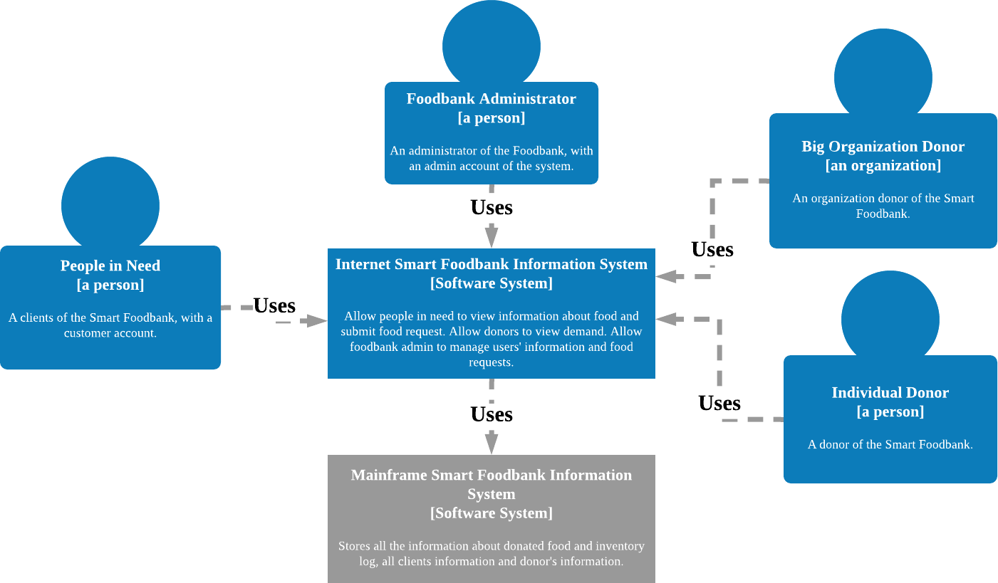

*[Figure 11.2] C4 Level 1: System Context Diagram*

In the Smart Foodbank System, there are four main stakeholders: The Smart Foodbank Administrator, the People in Need, Big organization Donors and the Individual Donors. The Foodbank stuff and People in Need shall have direct access to the system while the donor can only have a view. All of the stakeholders are connected through the central Smart Foodbank information system.

## KEY ARCHITECTURAL DESIGN DECISIONS

Based on our functional and quality scenarios, we decided three main key drivers: Performance, Usability and Data processing Capability in relation to the choice of Reference Architecture. The system shall have a high performance in order to operate normally and collect data from all administrators’ input. Usability is also considered as a key driver, because end users shall be able to understand the contents and achieve specified goals with effectiveness, efficiency and satisfaction. In addition, the system shall have an effective structure with high capability of data processing to support data flow from different interfaces to the database. Therefore, by adding those key drivers in considerations, we performed a more in-depth analysis (Table 11.1) to select the alternative.

|  |  |  |  |  |  |
| --- | --- | --- | --- | --- | --- |
| **Name of Alternative** | **Pros** | **Cons** | **Performance** | **Usability** | **Data**  **processing capability** |
| Web application | Fast page loading; Simple | Does not support | 7 | 4 | 6 |

|  |  |  |  |  |  |
| --- | --- | --- | --- | --- | --- |
|  | deployme nt | rich interacti on |  |  |  |
| Rich Internet application | Access from variety of platforms; “rich” interactio n; simple deployme nt and updating | Longer page loading times | 8 | 9 | 9 |
| Mobile application | Supports “rich” user interactio n | Screen limitatio n | 7 | 7 | 8 |
| Server application | Ease of effort and maintenan ce | Not reliable due to use of centraliz ed databas e | 5 | 4 | 5 |
| Rich Client application | Better data processing rich graphic user interface |  | 4 | 8 | 7 |

*[Table 11.1] Support the Selection of Alternatives*

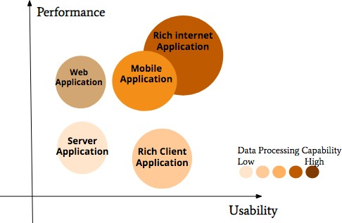

*[Figure 11.3.1] Decision support chart*

After in-depth analysis, Rich Internet Application with the effective performance, usability and high capability of data processing is the ideal architecture to choose. However, based on our stakeholder research, 65% end users use both mobile app and website browsers, so rich internet application itself is not sufficient. Additionally, Food bank managers need to send and receive information immediately from smart food bank system and store the data into same database. (Figure 11.3.1)

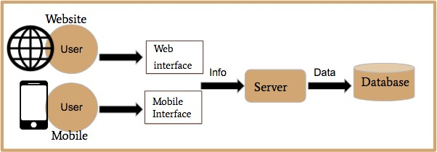

*[Figure 11.3.1] initial system structure*

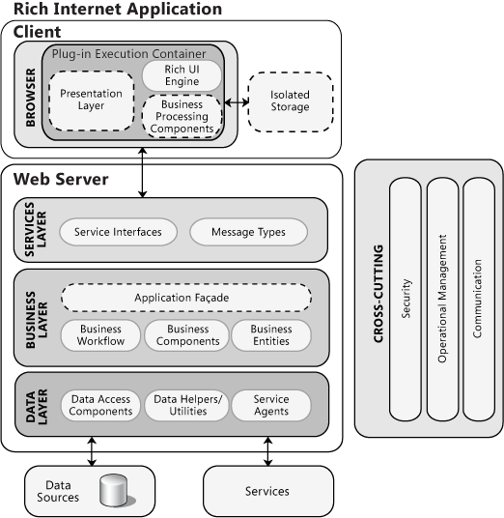 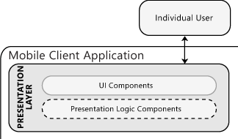

*[Figure 11.3.3] Reference Architecture*

The next step we have chosen our reference architecture - Rich Internet Application and Mobile application Hybrid Architecture. The architecture remains N-tier layers including presentation layer for UI component, Services layer for service interfaces, Business layer for business workflow, and Data layer for data access components. The direction of data flow could only from upper layer to bottom layer, in other words, each layer is dependent on the upper layer and responsible for the bottom layer. In addition, we will mainly focus on Rich Internet Application with the mobile application interface, using only presentation layer of Mobile Client Application (IOS/Android Interface) for mobile users.

Presentation layer of Mobile application will connect to the web server directly for processing data downward and finally integrated into a main database.

# OPEN ISSUES

|  |  |
| --- | --- |
| **Key Drivers** | **How it is being addressed** |
| **People in need request food** | **Fully addressed:** The system allows the people in need to select the food they require every Monday to Tuesday of the week and indicate the  food substation if any. |
| **The foodbank Request food from the big donors** | **Fully addressed:** On Wednesdays the system provides the food bank with a big list of needed food and allows them to order them from the big  donors. |
| **The food bank allows the individual donors to donate.** | **Fully addressed:** On Thursday, the foodbank manager looks at the food that can provided by the big donors and posted the food that cannot |

|  |  |
| --- | --- |
|  | be obtained on the portal where the donors can look at it and donate the needed food. |
| **The food bank distributes the food to the people in need.** | **Fully addressed:** On Friday, the foodbank staff look at the food available ad match it with the people's needs on first come first serve bases and  wait for it to be picked up. |

The key drivers are fully addressed with the system. The people in need request the food through the system and the system allows them to add any substitutions just in case the food they requested cannot be obtained. This way the system helps in reducing food insecurity and prove the people in need with the exact amount of food which is enough for them.

The food bank system allows the food bank manager to directly communicate with the big donors, this way it helps the donors understand the food bank needs and only provide them with the needed food to help in reducing food wastage.

The new system also encourages the community to help the foodbanks and donate food, the portal will allow them to look at the needed food and donate it to the food bank. This will allow the foodbank to get the needed food from the donors if the big donors don’t donate the needed food.

The system will also help in food distribution, the system creates a page for each donor with their food request, this will allow the staff to give away the food based of their needs and the food substitution in the first come first serve basis.

Although the system allows the food bank to reach the goals and provide people with the needed food in an easy manner, there are some issues and limitations we need to address and find ways to fix them.

|  |  |
| --- | --- |
| **Open Issues:** | **How is this addressed?** |
| **Food inadequacy** | **Partially addressed:** The food bank will open a portal so people can contact the food bank if they can donate. |
| **Equity and fairness** | **Partially addressed:** First come first serve (People who submit the request first). Next step: Find a way to differentiate People in Need fairly based on the needs not the first come first serve basis. |
| **Data Loss** | **Fully addressed:** Fluented Data collector will work as a back-end data collector and efficiently collect, aggregate and move large amount of streaming events data. |

## Food inadequacy:

The system works in a way to provide the people in need with the food they need based on the food requests they submit online. The system does a good job by providing the food bank manager with a report of the total food requested and the total food substation list if any. These lists help the foodbank manager order the food from the big donors. An issue that remains unresolved is food shortage. On one

hand, our process partially addresses this issue, as mentioned we allow the community to engage with the food bank and donate the food the big donors cannot provide. On the other hand, we would have to keep in mind that it still does not guarantee sufficiency. So, we must come up with other solutions to ensure that the food the people in need ordered can be obtained.

**Potential solution:**

A new portal can be created where the foodbanks can communicate together and request food if the other food banks have extra food. This way can help the food banks communicate and get the food they want if the other foodbanks have extra.

Another solution is to create another new portal where we can talk to other community centers and charity organizations where they would request and order the missing food, which will help the food bank extend the connections and get more people to donate.

## Equity and fairness:

The second issue we are facing is food distribution when we do not receive enough food for everyone. In this case food distribution would be an issue because we won’t be able to provide the people with the food they need. We fixed this problem partially as we suggested the food distribution would be based on first request first serve basis. This can be issues because people’s needs differ, and it is not fair to provide food based on first come first serve. Our next step would be finding a way to differentiate People in Need fairly based on the needs not the first come first serve basis.

**Potential solution:**

A solution would be we create a storage room where we have lift over foods from the past weeks or accept walk in donations. This way will help us have food in the storage to provide to people in case we run out of food and do not have enough for everyone.

## Data Loss:

When creating the system, we wanted to find a way to differentiate all the data input and organize them in a way for easier retrieve and save the data from loss at the same time. This issue has been fully addressed using Fluented data collector working as a back-end data collector and efficiently collect, aggregate and move large amount of streaming events data. It will clear the data and differentiate them based on the type of information. It will differentiate the personal information from the request information and store the data as a back end, in case anything happens to the database.

## The system accessibility:

A problem we face is that the system is mainly based on requests. We have to keep in mind that internet might not be accessible to everyone. A lot of people in need are seniors, do not use technology or do not have internet access. So, we would have to keep in mind we would like to make our system more accessible to everyone in need to get the food they want. At this moment we do not have a solution for this problem, but we can allow people to walk in to request food if they don’t have access to the system.

## The system doesn’t facilities communications between multiple foodbanks:

As mentioned earlier we do not have any means of communication with the other foodbanks. Implementing a portal will allow the foodbanks to communicate, provide each other’s with extra food if they have and work together to make sure the people in need get the food they need.

## We assume that people will only donate the asked food:

As mentioned, we get the food the big donors cannot provide from the individual donors, we assumed them they would donate. Implanting other portals with different communities and organizations will help the food bank get the needed food.

# CHANGES MADE IN THE COURSE OF ANALYSIS

We had some changes from the vision. In the vision we started that the second harvest would work with as a storage room for the food banks where the big donors’ donations would go directly to them. After designing our system, we decided there would be no point of adding the second harvest in the system. It would be more efficient to have direct communications between the foodbank manger and the big donors. This will make it easier for the foodbank managers to get the food they the need and will make it easier to address issues in the food provided.

Another change we made was the addition of the smart box. We said it would be a great idea to allow the individual donors to scan the item they have and want to scan and drop it in a smart box where it only accepts the scanned item. The foodbank staff can then pick up the food from the box. We decided we would not go further with this idea at this time because it would require a lot of time to coordinate the box with our system and it is way out of the scope.

**Reference**

*1. Household Food Insecurity in Canada. (2018, February 22). Retrieved April 9, 2019, from https://proof.utoronto.ca/food-insecurity/*